To,
The Principal Secretary,
Higher Education Department,
Govt. of West Bengal. Dated 30th August, 2024

Sub: Response to query Memo No. 21-Pr.Secy-HED/24 dated 29.08.2024.

Respected Sir,

In response to the query from the Higher Education Department, Government of West Bengal, Memo No. 21-Pr.Secy-HED/24 dated 29.08.2024, the information is provided below:

Name of the Suspended Employee | Name of the Office/Institution with address | Suspended from | Reason for suspension | Any other details
N.A. | Ghoksadanga Birendra Mahavidyalaya, Ghoksadanga, Cooch Behar. | N.A. | N.A. | N.A.

Thanking you,
Yours sincerely,
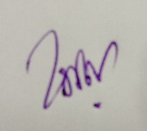
(DR. GOBINDA RAJBANSHI)
Principal.

